**Chapter 1 – Basic Concepts**

Table of Contents

1.1 Introduction 2

1.3 Charge and Current 3

1.4 Voltage 4

1.5 Energy and Power 5

1.6 Circuit Elements 6

1.7 Applications 7

## 1.1 Introduction

An electrical circuit is an inter-connection of electrical elements (voltage source, resistance, conductors etc.). Electrical circuits can be open or closed.

## 1.3 Charge and Current

Charge is an electrical property of the atomic particles of which matter consists. Charge is measured in coulombs ().

Current is the time rate of flow of charge. It is measured in amperes ().

With regards to distance travelled by the charge, if the distance between two points of a connection is , the total distance travelled will be , since current must also flow back.

Example 1.2

At , find .

## 1.4 Voltage

Voltage is the energy needed to move a unit charge through a conductor. The unit is volts ().

– Potential at point with respect to ground

– Potential at point with respect to ground

## 1.5 Energy and Power

Energy is the ability to do work. The unit is Joules ().

Power is the rate at which work is done. The unit is Watt ().

Sign Convention

+ve power is when energy comes from the positive side and -ve power is when energy comes from the negative side.

Practice Problem 5.5

## 1.6 Circuit Elements

Independent Voltage Source

 

Independent Current Source

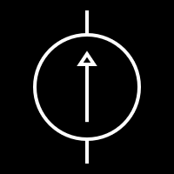

Dependent Voltage Source



Dependent Current Source

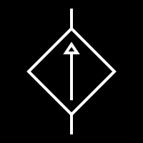

## 1.7 Applications

Electric Bill is measured in KWH. The rate changes based on usage.

Example 1.9

Average Rate